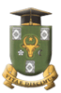
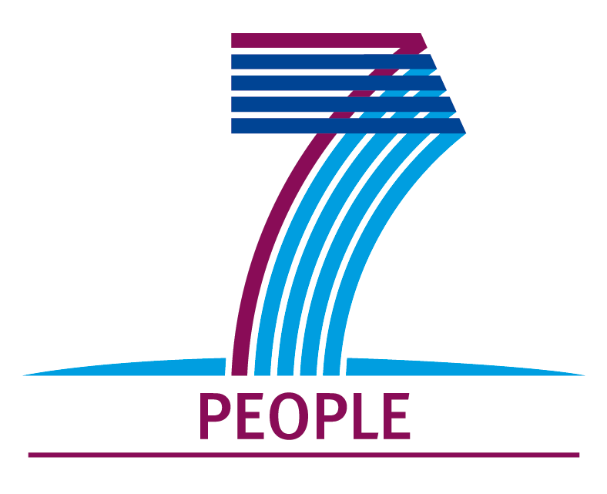
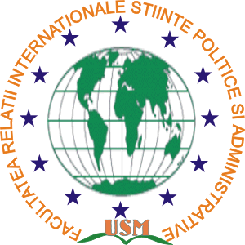

Moldova State University, Faculty of International Relations, Political and Administrative Sciences has the honour to invite you to attend the International Scientific Conference
”Political Science and the Changing Society”,
dedicated to the 20th anniversary of the Faculty of International Relations, Political and Administrative Sciences.
Chişinău, 13 November 2015.

The processes of change have marked the development of the Republic of Moldova from the beginning. Political change triggered a process of modernization which included all areas of social life being carried on under the slogans of democratization and liberalization. Political modernization has always been a great project for the future of Moldova’s society.
Moldovan political science is called upon to give the theoretical support necessary for the processes of change. The Faculty of International Relations and Political Sciences of Moldova State University has been one of the important centers which underpinned the establishment and affirmation of political science in the country. Celebrating 20 years of the Faculty of International Relations, Political and Administrative Sciences is an opportunity for assessment and mapping of new targets
The conference dedicated to the event aims to bring together academics, government officials, politicians and civil society experts, who will discuss Moldova’s political modernization issues, aspects related to public administration reform in the context of efforts to Europeanize the country and promote its interests internationally by setting cooperation relations with other states and ensuring national security. Attaching status of an international scientific forum to the conference will facilitate addressing topics from a comparative perspective, an appropriate framework for an exchange of experience with a theoretical and practical impact.
The speakers will present their papers and discussions will be held at the plenary sessions and workshops. The articles that will be sent must match the topic of the workshop - Annex 1. Submissions for publication must meet the conditions stipulated in Annex 2.
The conference will be held at Moldova State University, Faculty of International Relations and Political and Administrative Sciences (6, Testimiţeanu street) on November 13, 2015, from 9.30. The official languages of the conference are Romanian, English and Russian.

For additional information call: (+373 22) 797385, 797122, e-mail: frispausm@gmail.com

We look forward to see you there!

